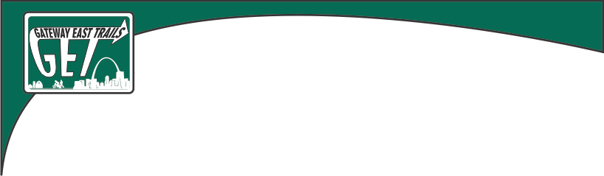

August 21, 2024

Lebanon City Council

Streets and Alleys Committee

Request for Use of City Hall Parking Lot

Gateway East Trails is requesting the use of the city hall parking lot on September 14, 2024, with a rain date of September 15, 2024 from 9:00 am to 2:00 pm, for parking and staging a planned city-wide bicycle ride event. This event is the 4th Annual Let’s Ride Lebanon (Illinois)! cycling event. The event is part of a statewide Let’s Ride Illinois! initiative sponsored by Ride Illinois. The event is a free, slow, family friendly 6.5-mile group ride on the streets of Lebanon visiting up to four sites. The first annual event that took place in 2021 attracted 14 riders ages 10-73. Additional sponsors are being sought to provide support at the three planned stops: Historic Trolley, Horner Park, and McAllister Park.

Riders will be instructed to ride to the right of the street in single file and follow traffic rules including stopping at stop signs and traffic control signals. There will be a request to the Lebanon Police Department to provide traffic control assistance at the intersection of Schuetz St and Madison St on the final leg of the ride. This was part of last year’s ride and the coordination worked perfectly. All riders will sign a release form when registering and a certificate of insurance can be provided to the city upon request. Attached is a map of the proposed route.

The purpose for this ride is simply to get individuals and hopefully families to ride together in the city demonstrating safe riding routes and practices. Last year there were 26 Let’s Ride events across the state during the ten-day window for this event. The event for Lebanon will be posted on Ride Illinois site and publicity for it goes statewide both pre- and post-event.

Thank you for your consideration.

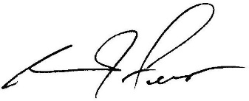

George J. Fero

Vice-President Gateway East Trails.

Let's Ride Lebanon - 2022

